* Project Specification
  + The project:
    - This will be a brief summary of my project. In this little paragraph you will be learning what minecraft mod I made, and Why I made it . So for this project what I had created was a minecraft mod specializing in the variety of weapons it brings to one's minecraft experience. Moving on, the reason i had chosen this for my project was because of one mod that led to the other the first is a magic mod, which allow you to shoot melee weapons
  + Solution Design
* Class Diagram  
  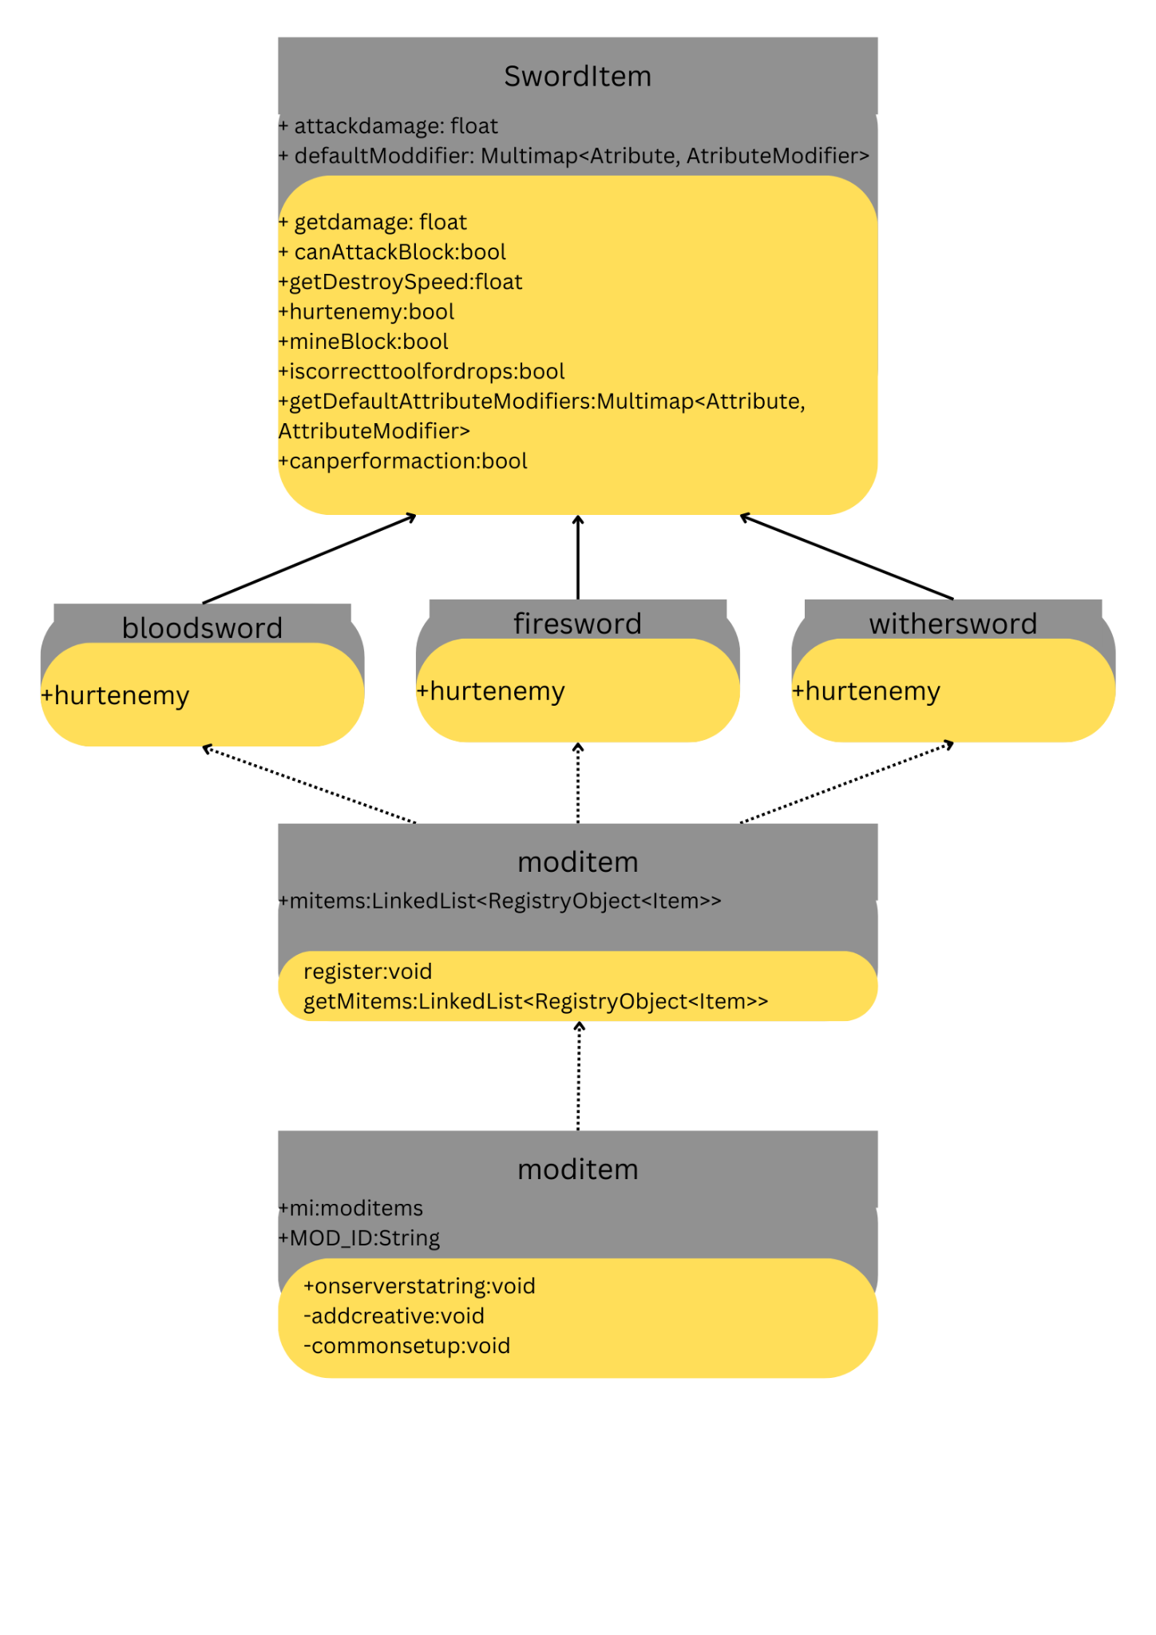
* A discussion of what was implemented and how it works (i.e., an explanation of your algorithms, solution scheme, data structure used, etc.);
  + Data Structure used:
    - Linked list:  
      I basically used this data structure in order to create better convenience with the list so that adding items into creative tabs would be more dynamic
      * So i expect the time complexity being O(n) due to using a for loop to add all the items into creative tab but if we exclude that more or less possibly O(1) if we don't include the minecraft methods
  + Implliments:
    - I extended the SwordItem class, because the sword item class specialized in weaponry, witnessed by the already existing minecraft vanilla swords.

Screenshots of the project:

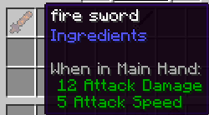

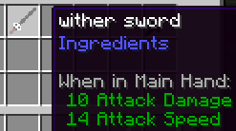

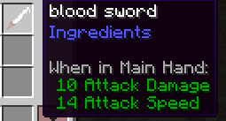

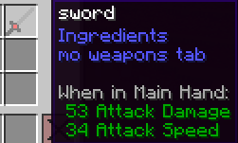

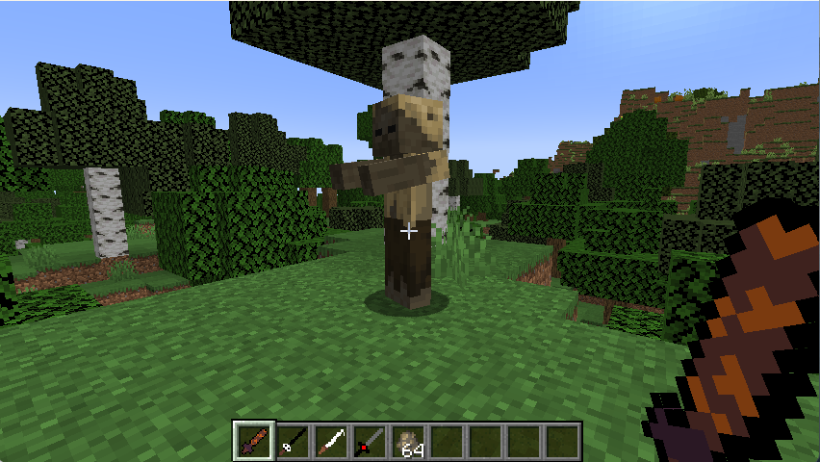

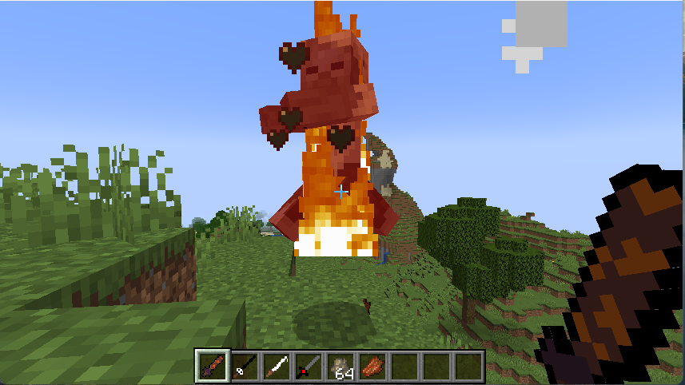

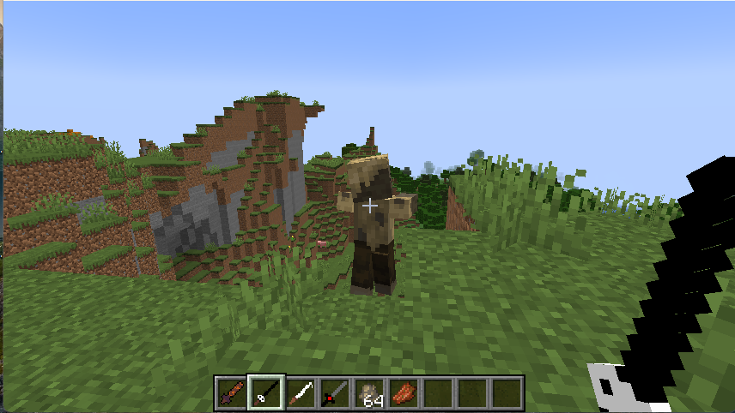

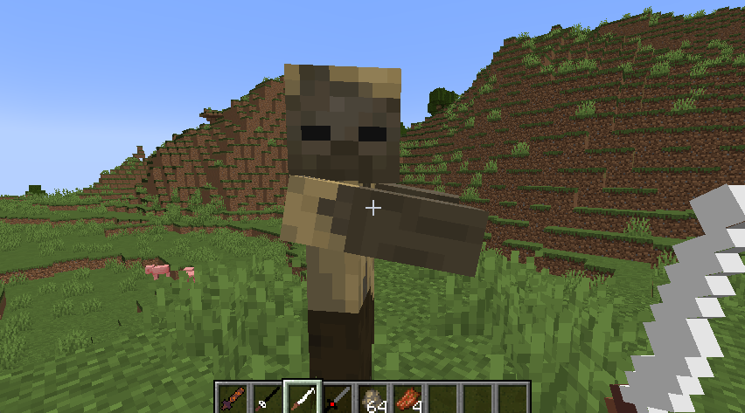

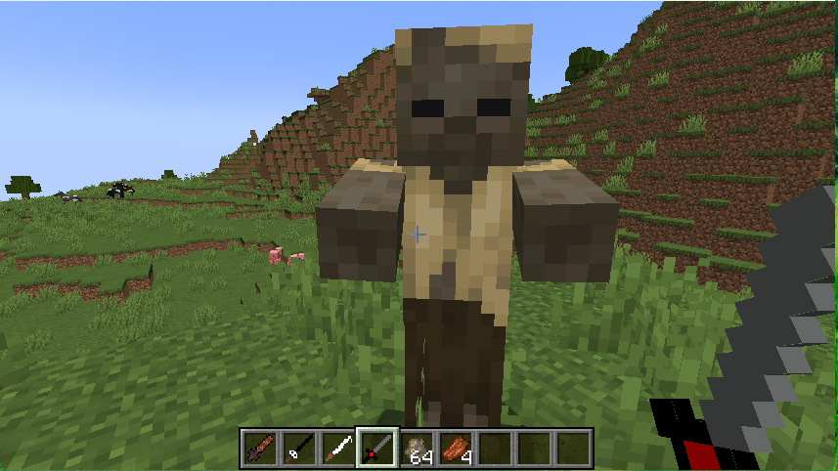

* Resources

<https://www.youtube.com/watch?v=55qUIf3GMss&list=PLKGarocXCE1H9Y21-pxjt5Pt8bW14twa->